  - Final Degree Project

PROJECT TITLE

  - Degree name
  - Curs 15/16

Author: .........................................
Director: .........................................
Date: .................
Locality: .........................

Space for dedications, acknowledgments... if applicable.

Project summary
Provide a summary of the project in the same language in which it was written.

Project summary (en anglès)

INDEX
1. Introducció ¡Error! Marcador no definido.
1.1. Font type 1
1.1.1. Headers and footers 1
1.1.2. About graphics 1
1.2. TITLE 2: OTRHOGRAPHY 2
2. BACKGROUND ¡Error! Marcador no definido.
3. BODY OF THE PROJECT ¡Error! Marcador no definido.
4. ECONOMIC STUDY ¡Error! Marcador no definido.
5. CONDITIONS FOR ITS EXECUTION ¡Error! Marcador no definido.
6. ENVIROMENTAL IMPLICATIONS ¡Error! Marcador no definido.
7. Conclusions 15
8. BIBLIOGRAPHY 17
9. APPENDICES 19
9.1. Annex 1 19
9.2. Annex 2 19

Do not put more than 3 levels in the index
Ensure that the numbering appears in the index

INDEX OF FIGURES
(If aplicable)

INTRODUCTION
There must always be an introduction to the project
You should talk about:
- Goal to be achieved
- Purpose of the project
- Scope of the project
You can use this format (margins, font, line spacing...) or similar

Proposal for different titles:

Font type

You can use other font types, but sans-serif like Times or Calibri, for exemple

Headers and Footers

You can use different headers and footers than the current ones, but it is important to number the pages

About titles
Do not add more depth to the titles
You can use this format for titles or a similar one

About styles

Always use different styles for normal text, titles, numbered paragraphs...

About figures and tables
When inserting figures (graphs, photographs...) or tables, always include a caption or table footnote, numbering them sequentially and providing an explanation.
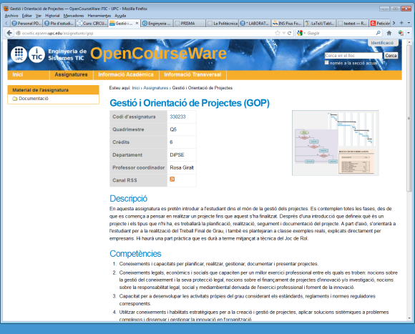
It is advisable to correctly number the figures and tables and include a caption for each figure and table. When referring to them in the text, you should reference them in the middle of the text, for example: As seen in Figure 1 or Table 1, ... When citing figures in the text for the first time, it should be done in sequential order (you cannot cite Figure 2 before citing Figure 1 when they are mentioned for the first time). You can use this forat if you like.
Figura 1: OCW of the iTIC degree
If it were a table, we would do:

Name | Data1 | Data2
Carles | 50 | 35
Mònica | 23 | 43
Pere | 12 | 43
Carla | 60 | 44

Table 1: Data on the scores obtained...
Title 4: Section Breaks

If you want to print double-sided (recommended for sustainability reasons), you can use odd-page section breaks so that chapters always start on the front page.

1.2. Title 2: Spelling

Always use the spell checker. Make sure to write well and pay attention to your spelling. It is important for the evaluation of the work.

More information
There are places at UPC where you can find more information that may be useful for writing your TFG correctly. Here are some links you can check if you're interested:
Recommendations for the preparation of academic works from the Library Service:
https://bibliotecnica.upc.edu/estudiants/6-passos-que-teu-tfg/tfm-sigui-exit
Writing resources from Language Services and Resources:
https://www.upc.edu/slt/ca/recursos-redaccio/criteris-linguistics/guia-redaccio-cientifica-ca
Writing support from the Library Service:
https://bibliotecnica.upc.edu/estudiants/6-passos-que-teu-tfg/tfm-sigui-exit/escric-meu-tfg/tfm

BACKGROUND
Use the appropriate title and subdivide it into more chapters if necessary.
You must explain the necessary prior information for understanding the project (current situation or starting data).
You can also talk about previous work in the same field, knowledge to consider for carrying out the project...

BODY OF THE PROJECT
Use the appropriate title. You will need to divide it into the chapters you consider necessary. This will depend greatly on the type of project you are doing. As a guideline, you can address the relevant topics from the following list, among other topics that may suit you:Viabilitat
- Calculations
- Computer processing
- Prototype development
- Fieldwork
- Justification of the chosen solution
- ...
If data are discussed or hypotheses are made, the descriptive part (descriptions, data, etc.) must be separated from the interpretative part (data analysis) in different sections.

ECONOMIC STUDY
If applicable, economic topics can be addressed, including cost estimates or a detailed budget (with the corresponding breakdown of measurements, prices, and total amount).
Depending on the type of project, these aspects might be addressed in an earlier section along with the technical topics.
If necessary, you can use a different title.

CONDITIONS FOR ITS EXECUTION
If applicable and the project needs to be implemented, aspects such as the following can be included:Plec de condicions
- Planification
- Manuals
- Plans
- ...
It is possible to use a different title with subsections or to organize it into different chapters.

6. ENVIRONMENTAL IMPLICATIONS
If applicable, the environmental implications derived from the project can be discussed.

Conclusions
The conclusions reached and any future lines of work, if applicable, should be described. Emphasize, if relevant, the importance, application, or continuity of the project.

Bibliography
Include the bibliography consulted according to the guidelines explained at the library. You can find information in the library service:
https://bibliotecnica.upc.edu/investigadors/citar-elaborar-bibliografia
https://bibliotecnica.upc.edu/investigadors/referencies-bibliografiques

Annexes
Annexes that are deemed appropriate can be added with relevant information that is not included in the project report.

Annex 1

Annex 2
...

